**WEEK 1 : Design patterns and principles Handson**

**Exercise 2 : Factory pattern :**

**Folder Srtucture :**

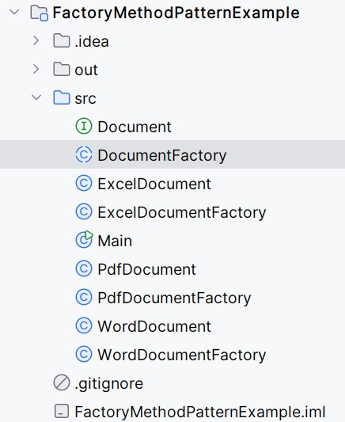

CODE :

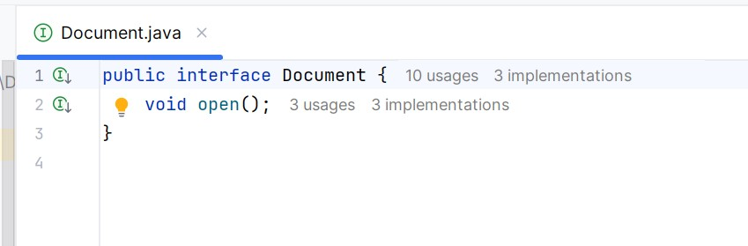

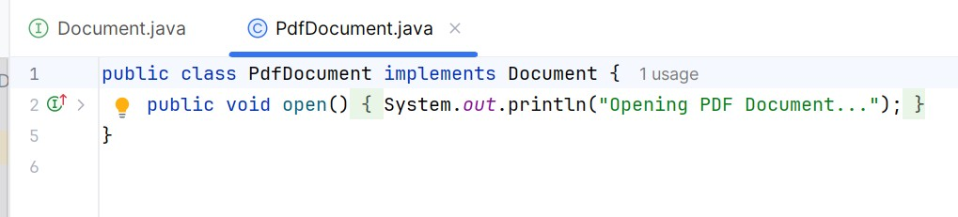

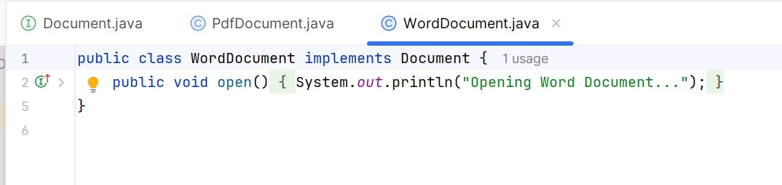

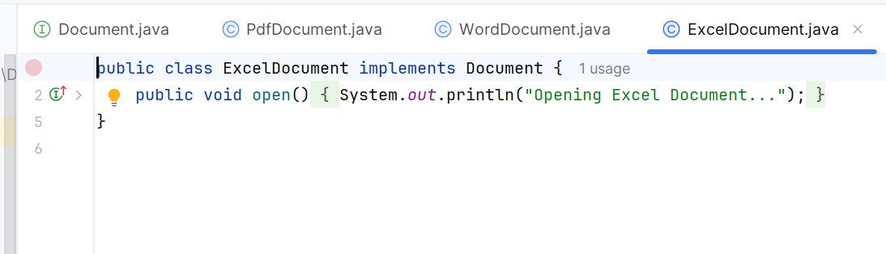

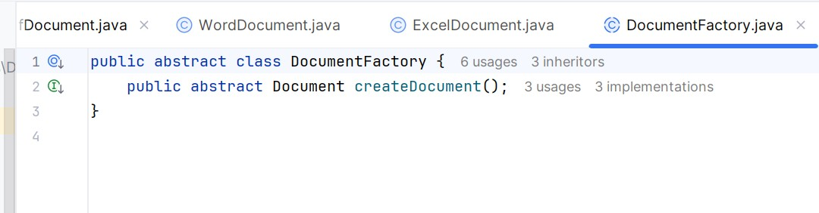

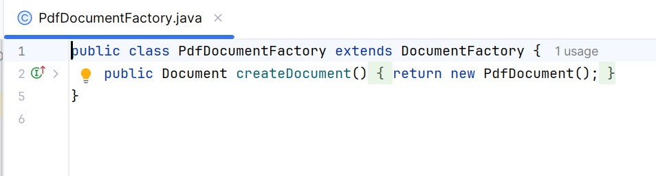

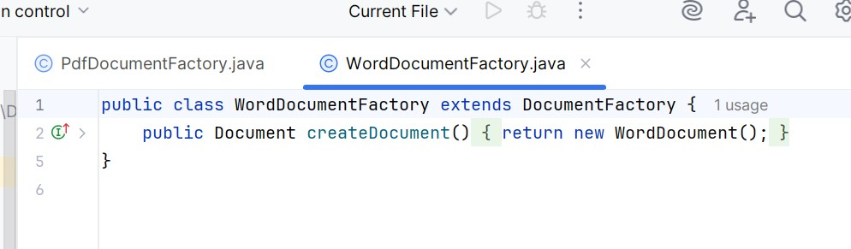

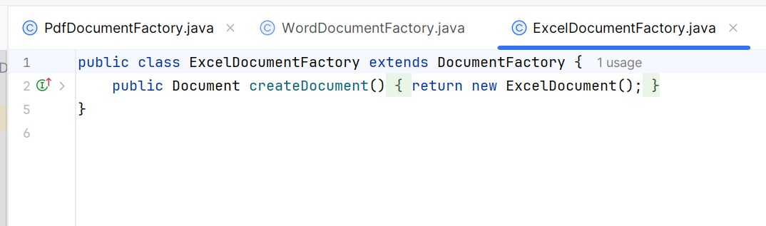

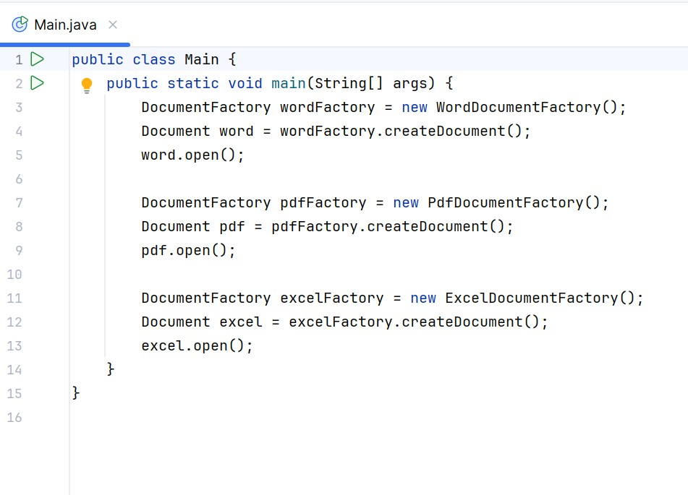

OUTPUT :

